





WINCHESTER


SCHOOL OF ART

OPEN DAY PROGRAMME SATURDAY 7 JUNE
WELCOME

Immerse yourself in the atmosphere of our creative campus and be inspired by our students’ work and influences at Winchester School of Art (WSA).

Explore your favourite subject, discover the amazing opportunities you’ll have here and visit the spaces and facilities that you’ll study in. Our facilities are filled with a diverse range of equipment to support you during your studies, including:

- High-spec computer suites with Mac and PC computers.
- Digital resources including consoles, VR and AR, multiple photography studios and an editing suite.
- Specialist printing equipment including laser cutting, 3D printer and scanner and a Mimaki fabric printer.
- On-campus specialist art and design Gallery and Library.
- Fashion studios equipped with a full range of sewing machines including
multi-thread overlockers, presses and cutting tables.
- A range of knitting machines including single, double bed and computerised Shima Seiki knitting machines.
- Bright weaving workshops including AVL dobby looms and a TC2 digital loom.
- Industry standard software across all disciplines including CLO 3D, Unity, Blender and the full
Adobe suite.
- Sculpture workshops, including a bronze foundry with ceramic kilns, meta and plastic fabrication shop, letterpress printing machines and etching presses.
- Large screen-printing facilities and dye-labs.
- Winchester West Wing, delivering leading-edge fashion leadership education in a contemporary and modern environment.
- Capital House will be the brand-new home of our Creative Computing and Games Design & Art programmes. This new building will offer our students access to industry standard facilities, including an Electronics workshop and a Social Games Space.

DISTANCE FROM WSA TO SOUTHAMPTON
DISTANCE FROM WSA TO LONDON

17 mins
22 mins
60 mins
1hr 40 mins
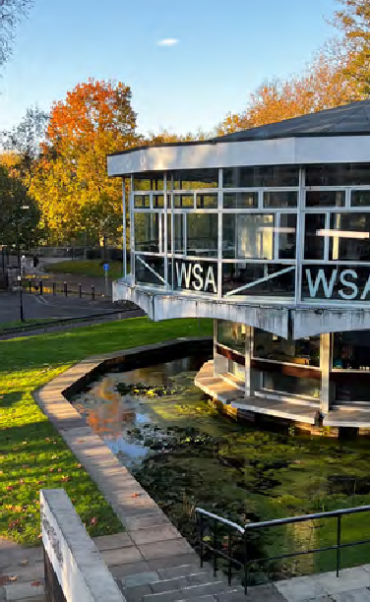
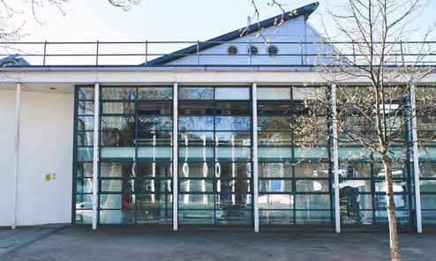
2

THE CITY OF WINCHESTER
Winchester is a vibrant city with diverse cultural life. Whether you want to spend your free time learning about the city’s history or socialising with friends, Winchester has it covered.

RANKED 8TH FOR ART
AND DESIGN RESEARCH QUALITY
Complete University Guide, 2025

DISCOVER FUN AND
INDEPENDENT PLACES TO EAT AND DRINK SUCH AS:
  - Forte Kitchen
  - Three Joe’s Pizza
  - Queen Inn (pub and microbrewery)
  - Open House Deli
  - Gurkha’s Inn

EXPLORE THINGS TO DO INCLUDING:
  - Unique and lively shopping such as The Hambledon and Anthropologie.
  - Independent cinema and theatres.
  - New leisure centre with fantastic facilities.

DELVE INTO THE HISTORY OF WINCHESTER AND ENJOY NATURE’S BEAUTY, VISIT:
- St Catherine’s Hill -
a 30-minute walk from WSA with picturesque views over the city (perfect for a picnic)
- Winnall Moors nature reserve close to campus
- Winchester Cathedral
- Wolvesey Castle

SUBJECT DROP-INS (See pages 4 and 5 for more details)
CREATIVE COMPUTING: Learn about Augmented Reality, Kinect, Robotics, Microscopy and Biosensing.
FASHION DESIGN: Meet the team 1-2-1 and learn more about fashion futures at university and beyond.
FASHION MARKETING WITH MANAGEMENT: Discuss the programme with the team and student ambassadors.
FINE ART: Join the programme leader for an art chat.
GAMES DESIGN & ART: Meet the team, play some games created by our students, and learn more about the course.
GRAPHIC COMMUNICATION: Explore the playful and open-ended approach to a Graphic Communication workshop through creating a custom Risograph print; starting with geometric source material to layer, cut, mask and fold.
LUXURY BRAND MANAGEMENT: Learn about our new course and find out where it could take your career.
SUSTAINABLE LUXURY (TEXTILES): Meet staff and students from the course and see the latest textile work on display. Prospective students are welcome to join us at 11:00 for an interactive workshop.
Places are available on a first come, first served basis.

DISTANCE FROM WSA TO THE CITY CENTRE
DISTANCE FROM WSA
TO ERASMUS PARK ACCOMMODATION

5 mins
2 mins
4 mins
15 mins
5 mins
10 mins
3

SCHEDULE OF EVENTS

WELCOME TALKS | TIME | DURATION | LOCATION
Welcome talk | 10:00 | 11:10 | 30 mins | West Side Lecture Theatre Building, West Side Lecture Theatre
Student Life talk | 10:35 | 11:45 | 20 mins | West Side Lecture Theatre Building, West Side Lecture Theatre
SUBJECT TALKS | TIME | DURATION | LOCATION
Creative Computing | 11:15 | 45 mins | East Side Building, Level 2, Lecture Theatre B
Fashion Design | 11:15 | 45 mins | West Side Building, Level 2, Lecture Theatre A
Fashion Marketing with Management | 13:15 | 45 mins | West Side Building, Level 2, Lecture Theatre A
Fine Art | 12:15 | 45 mins | West Side Building, Level 2, Lecture Theatre A
Games Design and Art | 12:15 | 45 mins | West Side Lecture Theatre Building, West Side Lecture Theatre
Graphic Communication | 13:15 | 45 mins | West Side Lecture Theatre Building, West Side Lecture Theatre
Luxury Brand Management | 12:15 | 45 mins | East Side Building, Level 2, Lecture Theatre B
Sustainable Luxury (Textiles) | 13:15 | 45 mins | East Side Building, Level 2, Lecture Theatre B
SUBJECT DROP INS | OPEN TIMES |  | LOCATION
Creative Computing | 10:00 - 15:00 |  | West Side Building, Level 1, Room 1163
Fashion Design | 10:00 - 15:00 |  | West Side Building, Level 2, Fashion Studio 4
Fashion Marketing with Management | 10:00 - 15:00 |  | East Side Building, Level 2, Fashion Marketing Studio 1
Fine Art | 10:00 - 15:00 |  | West Side Building, Level 2, Library
Games Design and Art | 10:00 - 15:00 |  | East Side Building, Level 2, Rotunda
Graphic Communication | 10:00 - 15:00 |  | East Side Building, Level 3, Room 3013
Luxury Brand Management | 10:00 - 15:00 |  | East Side Building, Level 2, Fashion Marketing Studio 1
Sustainable Luxury (Textiles) | 10:00 - 15:00 |  | East Side Building, Level 2, Textiles Studio

4
FOLLOW PURPLE SIGNAGE FOR OPEN DAYS

OTHER ACTIVITIES |  | TIME |  | DURATION | LOCATION
Employability talk |  | 12:30 | 14:30 |  | 30 mins | East Side Building, Level 3, Harvard Lecture Theatre
Portfolio Advice Session |  | 10:15 | 13:15 |  | 30 mins | East Side Building, Level 3, Harvard Lecture Theatre
The Winchester Gallery |  | 10:00 - 15:00 |  |  | West Side Building, Level 1
The Quiet Room |  | 10:00 - 15:00 |  |  | South Building, Level 3, Seminar Room 6
TOURS | TIME |  | LOCATION |  | DESCRIPTION
Accommodation tour (self-guided) | 10:00 - 15:00 |  | Erasmus Park. Directions on Page 9 or ask our event staff. |  | Self guide around our Winchester School of Art dedicated halls of residence, Erasmus Park. You'll have the opportunity to view the common room, laundry room and an ensuite flat.  If you have any questions, please speak to our accommodation representatives at Erasmus Park or visit the Student Life Fair between 10:00 - 15:00. Information on how to get to Erasmus Park is included on page 8 and 9.
Campus Tours | 10:00 - 15:00 |  | East Side Building, Level 1, Café |  | Explore the fantastic facilities on offer here are Winchester School of Art with our university guides. You'll have the opportunity to see key facilities for our undergraduate degree programmes. Tours are on foot and take approximately 30 minutes. Last tour departs at 14:30.
DROP INS | TIME |  | LOCATION |  | DESCRIPTION
Student Life Fair | 10:00 - 15:00 |  | Marquee on the lawn outside Eastside Building |  | Head down to the Student Life Fair to find out more from our services how they support you during your studies.  Find out more on page 7.
Information Point | 10:00 - 15:00 |  | East Side Building, Level 1, Café |  | Ask questions and chat with our current student ambassadors and some of our academic staff. We'll be here to assist and direct you throughout the event.
Students' Union drop in | 10:00 - 14:00 |  | East Side Building, Level 1, Café, SUSU desk |  | Drop in to speak to Students' Union representatives about opportunities outside your degree. Chat to us about events, clubs and societies, and how we represent you during your studies.
WSA Library | 09:00 - 16:00 |  | West Side Building, Level 2 |  | Take a look around our on-campus library. Browse books, journals, magazines and special collections, such as Artists Books and Visionaires. Or chat with our library staff, on hand to help with any library questions.
Offer Holder drop in | 11:00-12:00 |  | East Side Building, Level 1, Café |  | A warm welcome to our offer holders!  A chance for anyone currently holding an offer with us to meet other offer holders and chat to our staff and students.

5

HEAR FROM OUR STUDENTS



“My course offered a study exchange program, which most other universities didn’t offer. I also read about the industry standard equipment that WSA had to offer which was a major pull factor.
I enjoyed the opportunity to experiment and determine a specialism that you wanted to pursue. I enjoyed the studio culture I built with other motion design students.
I studied abroad, which was a once in a lifetime experience that has helped shape me as a designer and opened my perspective.”
HAYDN LOVERBRIDGE
BA GRAPHIC ARTS (MOTION DESIGN) 2024

BA DEGREE SHOW

Winchester School of Art is proud to present its annual BA Degree Show, taking place this June 6 – 11. This free event transforms our campus into a dynamic exhibition space, showcasing the bold, innovative, and inspiring work of our graduating students on our undergraduate programmes.
If you’re joining us for the Open Day, make sure to explore the show while you’re here. It’s a fantastic opportunity to see what our students achieve during their time with us — and to imagine where your own creative journey could take you.

BE INSPIRED. BE CURIOUS. SEE WHAT’S POSSIBLE.
“In Fine Art we are offered so many opportunities to go on trips, at least once a semester we take a trip to London for a gallery day. And depending on
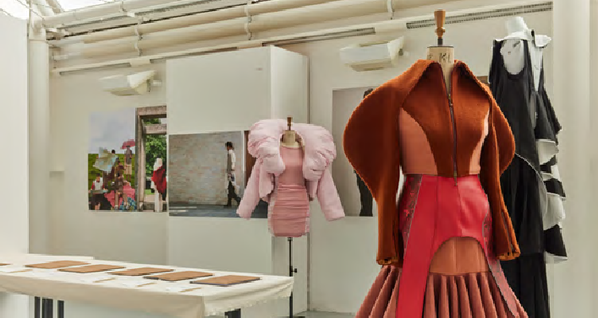
which pathway you choose there are always trips and projects curated to your chosen path.”

MEGAN BERRY BA FINE ART

2024

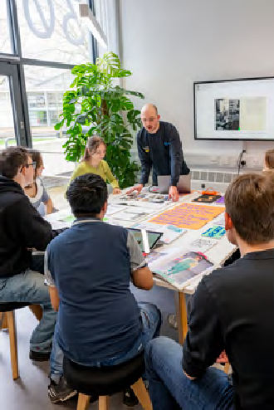
STUDENT LIFE FAIR

The Student Life Fair is the place to chat to support teams and find out all about university life, including:

DON’T FORGET:
OUR SUSU REPRESENTATIVES ARE LOCATED AT THE SUSU HELP DESK IN THE CAFÉ
THROUGHOUT THE EVENT TO ANSWER YOUR QUESTIONS.
- Accommodation
- Academic Skills Service
- Admissions
- Careers and Employability
- Disability and Inclusion
- Library
- Making your money work for you
- Study Abroad and Exchange
- Wellbeing

Don’t forget to attend our Student Life talks for more information, details can be found on page 4.

Try to make time to learn about clubs and societies, as they’re a big part of many students’ university experience.

When you join the University, you automatically become a member of the Students’ Union (known as SUSU), which is independent of the University. SUSU is here to represent the voice of students at every
level and ultimately make your university experience unforgettable. There’s a huge variety of events and social activities that you can take part in at our main campus, Highfield, and at WSA
including: WSA Freshers’ Fair

- Crafty workshops
- WSA Summer Ball
- WSA Careers Week

SUSU also has over 350 different sports clubs and societies. This includes over 50 societies in the creative industries such as:
  - Wessex Scene Magazine
  - Photographic Society
  - Hookers, Knitters and Stitchers Society
  - Games Society
  - Art Society
  - Music Society
  - A range of sports societies
  - Theatre Society


“My tips for an Open Day are to make sure you write down a list of questions (for staff and students that you’ll meet), take photos and walk around - either in a tour group or by yourself, it’s a good way to learn the space!”
HARRISON JONES BA FINE ART, 2023
7

MAKE YOURSELF AT HOME

Our welcoming and safe accommodation provides excellent facilities with 24-hour support and advice available, and a fantastic environment for you to make new friends and experience student life.
North Walls Road
Jewry Street


WHY LIVE IN UNIVERSITY ACCOMMODATION? YOU CAN ALSO REQUEST:
Capital House
Train Station

The Theatre Royal
ERASMUS PARK HALLS OF RESIDENCE
Brooks Shopping Centre
WINCHESTER SCHOOL OF ART

Walking time to Erasmus Park: 15 minutes
Bus Station
Winchester Cathederal
Wolvesley Castle
WINCHESTER WEST WING
High Street
Easton Lane
    - Includes a common room, laundrette and bicycle store
    - High-speed internet in all bedrooms and communal spaces
    - Frequent and good value travel options
between Winchester and Southampton
    - Support in cleaning communal areas from our domestic services team
- All utilities, use of laundry (with auto-dosing detergent) and contents insurance included
- Meet fellow WSA students and build your own community
- We are UK student accommodation code accredited
  - A quieter flat
  - A no-alcohol flat
  - Female only flats
  - To live with your friends (international and second, third and fourth- year students only)
8
Parchment Street
Park Avenue
Middle Brook Street
Lower Brook Street
River Itchen
To Erasmus Park/Riverside Way

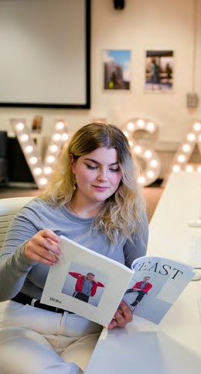
VISIT ERASMUS PARK HALLS

It is just a 15 minute walk to Erasmus Park. If you wish to drive, please DO NOT follow Google Maps as it will take you to the pedestrian entrance.

FROM WINCHESTER SCHOOL OF ART:
- Turn left onto Park Avenue and then turn left onto North Walls B333, keep left at the fork.
- Follow Easton Lane, drive past the pedestrian entrance and turn left onto Moorside Road.
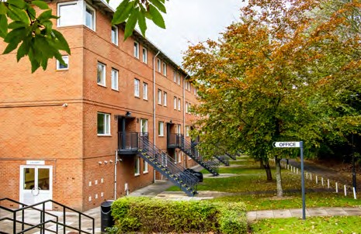
- Follow Moorside Road around to the left and turn left when you see the Erasmus Park sign.

FROM THE M27:
  - Leave the motorway at Junction 9
  - At the roundabout take the Easton Lane exit towards Winnall Industrial Estate
  - At the roundabout take the second exit
  - Turn right onto Moorside Road
  - Follow Moorside Road around to the left and turn left when you see the Erasmus Park sign.
You can park without a permit. Follow Open Day signage to the reception and common room for your accommodation tour.

“Most of the people I still hang out with today are those who I met in halls in my first year.
As a WSA student, it meant everyone at Erasmus Park was also from WSA. It created lots of opportunities to mingle, and I knew I would see
them again.”
NICOLE KARKUT
BA FASHION MARKETING WITH MANAGEMENT, FINAL YEAR

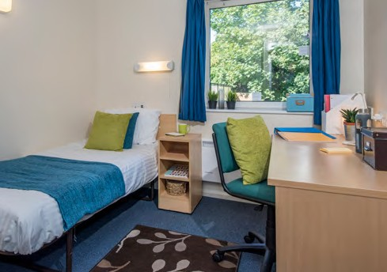
9

EXPLORE THE CAMPUS
Creative Services
Park Avenue

Use this map to help you explore the campus throughout the day. Want to find out more about the facilities? Head to the information point located in the cafe. Or take a guided tour with one of our student ambassadors.
To Park







North Walls To Erasmus Park/Riverside Way
Entrance
Student Life Hub 5
EASTSIDE BUILDING
234
1
Entrance
ADMIN & FASHION BUILDING
Student OfficeEntrance
Car Park (Staff/Students)
Entrance
SOUTH BUILDING
Entrance
WESTSIDE BUILDING
Entrance
Gallery

Library & Photography Studios
Westside Lecture Theatre
To City Centre

LEARN MORE ABOUT THE CAMPUS
AND FACILITIES
10

SOUTH BUILDING FIRST FLOOR
    - PC Suite
    - Games Hangar

THIRD FLOOR
    - Seminar Rooms 6-10
    - Quiet Room

WEST SIDE FIRST FLOOR
    - Winchester Gallery
    - Seminar Rooms 1161, 1163, 1165
    - MA Fine Art Studio
    - Media Stores
    - Mac Suite
    - Creative Computing Studios / Work

SECOND FLOOR
    - Library
    - Fashion Studio 4
    - Fine Art Studio
    - Lecture Theatre A
    - Motion Capture Suite

WEST SIDE LECTURE THEATRE BUILDING
    - West Side Lecture Theatre

ADMIN & FASHION BUILDING FIRST FLOOR
    - Main Reception
    - Student Office

SECOND FLOOR
    - Student Support
    - Fashion Studio 1
    - Fashion Studio 3

THIRD FLOOR
  - Fashion Studio 2

EAST SIDE BUILDING FIRST FLOOR
  - Students’ Union / Cafe
  - Computer Centre and Mimaki Printing
  - Printmaking Workshop
  - MA TD Studios
  - Digital Fabric Printer
  - Creative Services Centre
  - Textiles Dye Labs and Laundry
  - E-Textiles
  - 3D Printing
  - Fine Art Studios / Workshops

SECOND FLOOR
  - Mac Suite
  - Computer Centre 1
  - Assistive Technology
  - Lecture Theatre B
  - Fashion Marketing with Management
  - SLT (Textiles) Workshops
  - SLT (Textiles) Studio

THIRD FLOOR
  - Graphic Communication Studios
  - Seminar Rooms
  - Digital Suites
  - Harvard Lecture Space

Check-in


Campus Tours
1
2

Café
3

Information Point
4

Student Life Hub
5

Parking

Assembly Point

Winchester School of Art University of Southampton Park Avenue
Winchester SO23 8DL

023 8059 6900

www.southampton.ac.uk/wsa

11

LEARN MORE ABOUT WSA

PARTNERED WITH WOMEN IN GAMES, UKIE, RAISE THE GAME
MEMBER OF THE UK FASHION AND TEXTILE ASSOCIATION (UKFT)

COLLEGE MEMBER OF THE BRITISH FASHION COUNCIL

www.southampton.ac.uk/wsa

UK and EU enquiries: enquiries@southampton.ac.uk
+44 (0)23 8059 9699
WhatsApp at +4423 8000 0512

International enquiries: international@southampton.ac.uk
+44 (0)23 8059 2772
WhatsApp at +4423 8000 0512

 @uni_southampton_wsa  @unisouthamptonwsa  @unisoton_wsa
 @uni_southampton_wsa  @unisouthampton

DISCLAIMER:
This document is for information purposes only and is prepared well in advance of publication. While the University of Southampton uses all reasonable efforts to ensure that all statements, information and data contained in this document are accurate as at the date of publication, it reserves the right to make revisions or modifications to such statements, information or data at any time and without notice. Under no circumstances shall the University be liable for any reliance by
the reader on any information in this document.
© University of Southampton 2025
This document can be made available, on request, as an electronic version.
Correct at date of print, May 2025

